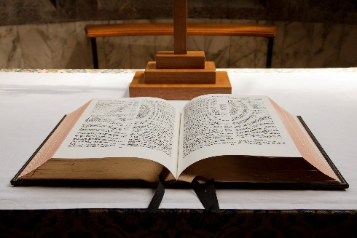

Smithfield

BAPTIST CHURCH

**January 2017**

QUARTERLY Newsletter

***New Year’s Resolution –***

***READ THE BIBLE***

***Why should I read the Bible?***

The Bible tells ***us about God*** and teaches us ***who we are***. We are made by God, in His image and for His glory. We were not created to live for ourselves.

The Bible teaches us that our rebellion against God has brought about much stress, suffering and conflict in ***our world***.

Most importantly, in the Bible, God guarantees that He will bring this brokenness to an ***end***.

God provided proof of this by raising His Son Jesus Christ from the dead and He promises that all who believe in Jesus Christ will also be raised to be with God forever – in perfect righteousness.

The Psalmist in Psalm 19 said that the Bible *“****revives the soul****”.* It makes “***wise the simple”*** and gives “***joy to the heart***.”

The Bible gives “***light to the eyes***”. It is “***pure, enduring forever and altogether righteous****”*.

In **Psalm 19:10** he says that the Bible is “***more precious than gold, than much pure gold****”;* it is *“****sweeter than honey, than honey from the comb****.”*

If you would like a ***FREE*** ***COPY*** of Luke’s Gospel (to get started) then please contact me.

And we warmly invite you to read and study the Bible with us on ***Sundays*** *at* ***10:30am or Tuesday night at 7:30pm.***

**Smithfield Baptist Church**

**742 Horsley Drive**

**(Cnr Horsley Drive & O’Connell Street)**

**Smithfield NSW 2164**

**Pastor Chris Athavle**

**Mobile: 0401 661 810**

**Email: office.smithfieldbaptist@gmail.com**

Visit our website www.smithfieldbaptist.org.au

Church Services

(every Sunday at 10:30am)

***Who is Jesus?***

*A series in John’s Gospel*

Bible Study

(every Tuesday at 7:30pm)

Reading & studying **1 Peter**.

***“How to live as a Christian in the middle of troubles.”***

Sunday School

(every Sunday at 9:00am)

All kids welcome

**ACTIVITES THIS MONTH:**

