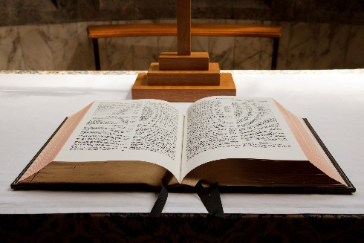

Smithfield

BAPTIST CHURCH

**June 2016**

QUARTERLY Newsletter

***“I can’t get no satisfaction”***

***The Rolling Stones***

Mother's milk comforts a crying baby because special substances are released - the baby experiences satisfaction and pleasure. The aroma of sizzling steak (or vegies), triggers the release of brain chemicals alerting us that pleasure is near. Whether milk or meat, food both nourishes our body and brings satisfaction and pleasure.

The pleasures that our human organs and senses enjoy do not come to us by accident. God gave us these pleasures to enjoy. God did not create us with any part of our anatomy that produces pain. God is good.

Consider the ear or the eye! Both are complexly engineered to give us sight and hearing. These organs help us function practically but they also help us enjoy beauty in music and art.

You are a miracle - made with the capacity to enjoy many things and appreciate beauty. But physical stimulation and enjoying beauty is not enough to satisfy the deepest longings of the heart.

We are made for a far richer pleasure and beauty. Our need for a committed loving relationship, security, joy and hope, cannot be found in milk or meat, marijuana or motorbikes, King Island cream or computer games, persimmons or porn. ***Every one of us can relate to the Rolling Stones’ song.***

King Solomon said, *I denied myself nothing my eyes desired; I refused my heart no pleasure. My heart took delight in all my work, and this was the reward for all my labor. Yet when I surveyed all that my hands had done and what I had toiled to achieve, everything was meaningless, a chasing after the wind; nothing was gained under the sun*. **Ecclesiastes 2:10-11**

Is chasing physical pleasure leaving you dissatisfied? You will never know true satisfaction or pleasure until you know God through Jesus Christ – His Son.

Jesus said, *"I am the bread of life. He who comes to Me shall never hunger, and he who believes in Me shall never thirst”*. **John 6:35**

If you want to hear about Jesus Christ then join us at church on Sundays at 10.30am.

**Smithfield Baptist Church**

**742 Horsley Drive**

**(Cnr Horsley Drive & O’Connell Street)**

**Smithfield NSW 2164**

**Pastor Chris Athavle**

**Mobile: 0401 661 810**

**Email: office.smithfieldbaptist@gmail.com**

Visit our website www.smithfieldbaptist.org.au

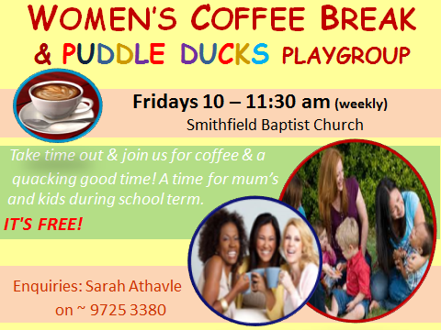

Activities this month

Church Services

(every Sunday at 10:30am)

***Who is Jesus?***

*A series in John’s Gospel*

Bible Study

(every Tuesday at 7:30pm)

Studying **2 Samuel**.

***Life of David***

Sunday School

(every Sunday at 9:00am)

All kids welcome

Monthly Community Dinner

26th June, 2016, 6:00pm

***“What if our government is unfair?”***

