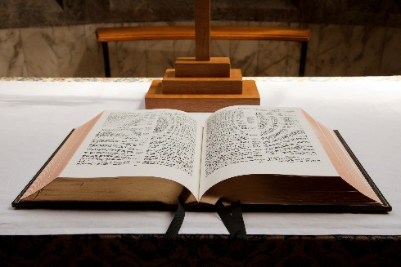

Smithfield

BAPTIST CHURCH

**October 2016**

QUARTERLY Newsletter

***Everybody Worships!!!***

Some claim to be **atheists** (“*I know* *there is no god*”). Others claim to be **agnostic** (“*I do not know for certain if there is a god*”). And still others claim to be **theists** (“*There is a god – but I do not know for certain whom He is*”).

These three groups would deny that they worship a god.

Even the prize winning novelist, David Foster Wallace, an agnostic, acknowledged that “***everybody worships***”. We worship the thing or being who we think will bring fulfilment, security and comfort.

In the west we most commonly assume that money, power, success or popularity will do this for us. Traditional societies look to family, relationships or community for fulfilment, security and comfort.

He alerts us to the fact that we choose our gods quite unconsciously. They are like the default settings on your mobile phone or PC. Someone has said that we can easily make good things “god” things.

We need to remind ourselves that none of these things are eternal and all of them can let us down. Most importantly they do not fully satisfy, comfort or save.

* *If you worship things or money – you will never have enough.*
* *If you worship beauty or your body – you will always feel ugly.*
* *If you worship power or success – you will always feel afraid and insecure.*
* *If you worship intelligence – you will end up feeling stupid or a fraud.*

**Who do you worship?**

**Jesus said,** *'Worship the Lord your God, and serve him only.'* **Matthew 4:10**



We warmly invite you to join us on

Sundays at 10:30am.

Please feel free to contact us if you have any questions.

**Smithfield Baptist Church**

**742 Horsley Drive**

**(Cnr Horsley Drive & O’Connell Street)**

**Smithfield NSW 2164**

**Pastor Chris Athavle**

**Mobile: 0401 661 810**

**Email: office.smithfieldbaptist@gmail.com**

Visit our website www.smithfieldbaptist.org.au

Church Services

(every Sunday at 10:30am)

***Who is Jesus?***

*A series in John’s Gospel*

Bible Study

(every Tuesday at 7:30pm)

Studying **1 Peter**.

***“Living victoriously in the midst of suffering.”***

Sunday School

(every Sunday at 9:00am)

All kids welcome

Christmas Dinner

27th November, 2016 6:00pm

**ACTIVITES THIS MONTH:**

